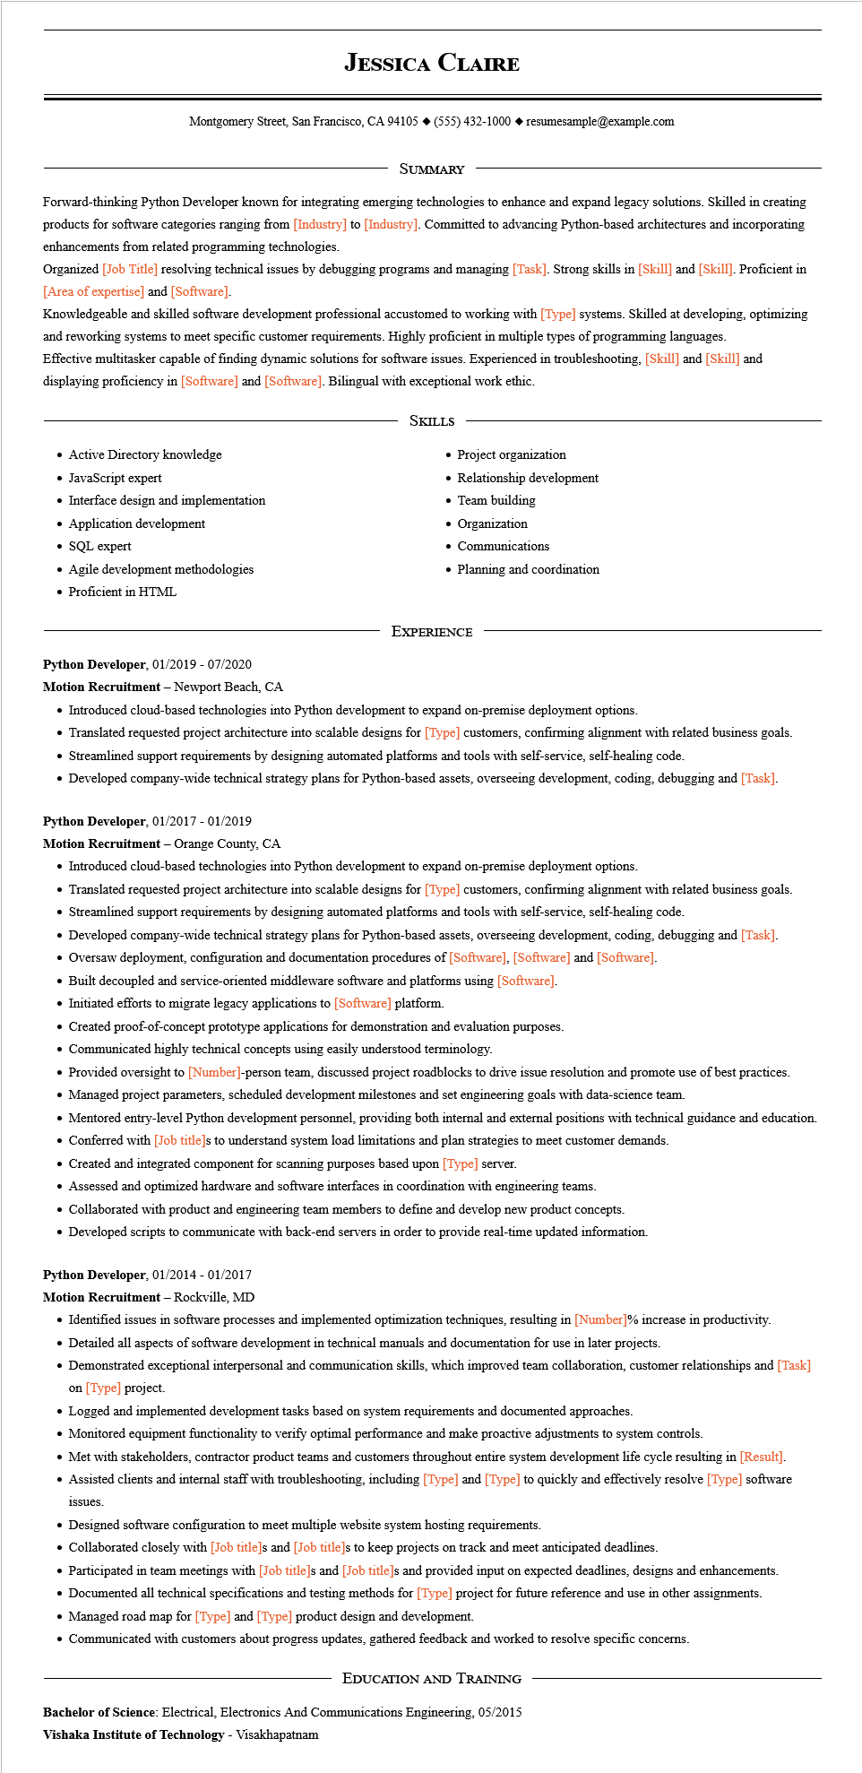
JESSICA CLAIRE
Montgomery Street, San Francisco, CA 94105 ♦ (555) 432-1000 resumesample@example.com
SUMMARY
Forward-thinking Python Developer known for integrating emerging technologies to enhance and expand legacy solutions. Skilled in creating products for software categories ranging from [Industry] to [Industry]. Committed to advancing Python-based architectures and incorporating enhancements from related programming technologies.
Organized [Job Title] resolving technical issues by debugging programs and managing [Task]. Strong skills in [Skill] and [Skill]. Proficient in [Area of expertise] and [Software].
Knowledgeable and skilled software development professional accustomed to working with [Type] systems. Skilled at developing, optimizing and reworking systems to meet specific customer requirements. Highly proficient in multiple types of programming languages.
Effective multitasker capable of finding dynamic solutions for software issues. Experienced in troubleshooting. [Skill] and [Skill] and displaying proficiency in [Software] and [Software]. Bilingual with exceptional work ethic.
SKILLS
• Project organization
• Active Directory knowledge
• JavaScript expert
• Interface design and implementation
• Application development
• SQL expert
• Agile development methodologies
• Proficient in HTML
• Relationship development
• Team building
• Organization
• Communications
• Planning and coordination
EXPERIENCE
Python Developer, 01/2019-07/2020
Motion Recruitment - Newport Beach, CA
• Introduced cloud-based technologies into Python development to expand on-premise deployment options.
• Translated requested project architecture into scalable designs for [Type] customers, confirming alignment with related business goals.
• Streamlined support requirements by designing automated platforms and tools with self-service, self-healing code.
• Developed company-wide technical strategy plans for Python-based assets, overseeing development, coding, debugging and [Task].
Python Developer, 01/2017 - 01/2019
Motion Recruitment - Orange County, CA
• Introduced cloud-based technologies into Python development to expand on-premise deployment options.
• Translated requested project architecture into scalable designs for [Type] customers, confirming alignment with related business goals.
• Streamlined support requirements by designing automated platforms and tools with self-service, self-healing code.
• Developed company-wide technical strategy plans for Python-based assets, overseeing development, coding, debugging and [Task].
• Oversaw deployment, configuration and documentation procedures of [Software], [Software] and [Software].
• Built decoupled and service-oriented middleware software and platforms using [Software].
• Initiated efforts to migrate legacy applications to [Software] platform.
• Created proof-of-concept prototype applications for demonstration and evaluation purposes.
• Communicated highly technical concepts using easily understood terminology.
• Provided oversight to [Number]-person team, discussed project roadblocks to drive issue resolution and promote use of best practices.
• Managed project parameters, scheduled development milestones and set engineering goals with data-science team.
• Mentored entry-level Python development personnel, providing both internal and external positions with technical guidance and education.
• Conferred with [Job title]s to understand system load limitations and plan strategies to meet customer demands.
• Created and integrated component for scanning purposes based upon [Type] server.
• Assessed and optimized hardware and software interfaces in coordination with engineering teams.
• Collaborated with product and engineering team members to define and develop new product concepts.
• Developed scripts to communicate with back-end servers in order to provide real-time updated information.
Python Developer, 01/2014 - 01/2017
Motion Recruitment - Rockville, MD
• Identified issues in software processes and implemented optimization techniques, resulting in [Number]% increase in productivity.
• Detailed all aspects of software development in technical manuals and documentation for use in later projects.
• Demonstrated exceptional interpersonal and communication skills, which improved team collaboration, customer relationships and [Task] on [Type] project.
• Logged and implemented development tasks based on system requirements and documented approaches.
• Monitored equipment functionality to verify optimal performance and make proactive adjustments to system controls.
• Met with stakeholders, contractor product teams and customers throughout entire system development life cycle resulting in [Result].
• Assisted clients and internal staff with troubleshooting, including [Type] and [Type] to quickly and effectively resolve [Type] software
issues.
• Designed software configuration to meet multiple website system hosting requirements.
• Collaborated closely with [Job title]s and [Job title]s to keep projects on track and meet anticipated deadlines.
• Participated in team meetings with [Job title]s and [Job title]s and provided input on expected deadlines, designs and enhancements.
• Documented all technical specifications and testing methods for [Type] project for future reference and use in other assignments.
• Managed road map for [Type] and [Type] product design and development.
• Communicated with customers about progress updates, gathered feedback and worked to resolve specific concerns.
EDUCATION AND TRAINING
Bachelor of Science: Electrical, Electronics And Communications Engineering, 05/2015
Vishaka Institute of Technology - Visakhapatnam

